MIA-6 routine analysis instrument workstation
(microcomputer multi-function automatic titrate meter)

FJA-2computer controlled automatic titration system
（Introduction）

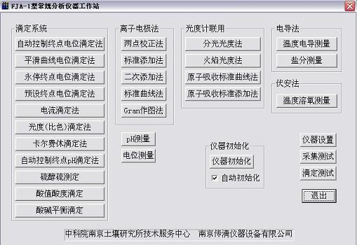
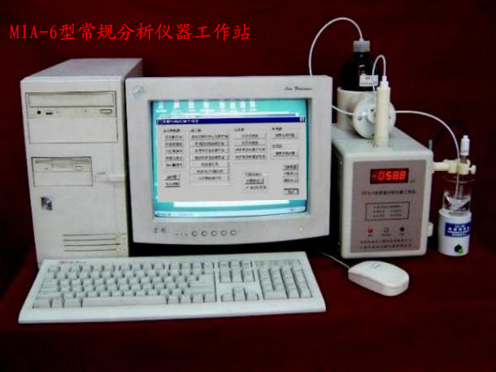
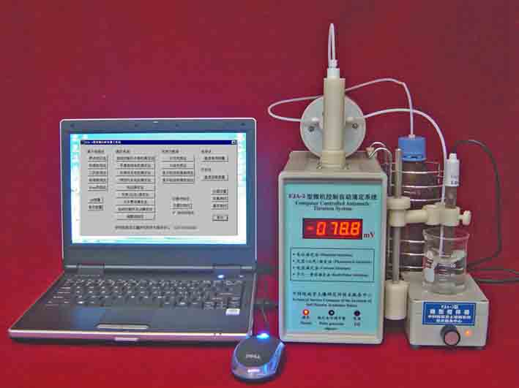
◎The MIA-6 routine analysis instrument workstation and FJA-2computer controlled automatic titration system (next called workstation) is one kind of new conventional microcomputer multi-function automated analysis instrument, it has the combined type, multi-function(Respectively is 25 and 22 application software), the RS232 standard communication (also may use the USB connection through transformation), on the one hand the titrate on the other hand plotting, the titration curve atlas and the determination result can save the hard disk, the Windos platform operation, Chinese menu or Eglish menu and operation prompt, the performance price is better than and so on the characteristic. May set up each kind of conventional laboratory like water quality determination and the soil fertility using the workstation determines the laboratory isochronism, many instruments did not need to buy, like pH meter , ion meter, each kind of automatic titrate meter, the Conductivity meter, dissolves theoxygen meter and so on. Therefore, it in various branches and sectorsof a national economy's the and so on. scientific research, Education experiment, Environment examination, medicine health, petroleumchemical industry, geological metallurgy and agriculture laboratory obtains the widespread application. The workstation contour and the application software function like chart shows.
In the workstation function, the Electric potential titration (acid-base titrations, precipitation-titration,and oxidation-reduction titration and so on), the luminosity titrimetric method, the amperometric titration , the Karl-Fischer titration to grade application function software, can adapt each kind of titrate, is a pivotal part. Several kind of titration curves following chart shows.
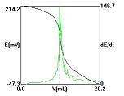
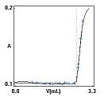
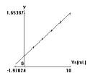
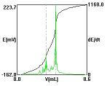

◎Workstation main technical performance
1) Signal voltage measuring range: -1999.9mV~1999.mV
minimum reading: 0.1mV, auto-distinguishing polarity
2) Accuracy of measuring voltage: 0.025%±2 character of the reading.
3) Input impedance: >10¹²Ω
4) Accuracy of titration± 0.01mL
5) Minimum feeding volume: 0.001mL
6) Titration error: ≤0.2% (0.1mol/L HcL titrates 0.1mol/L NaOH)
7) The titration curve atlas and measured results can be stored, printed, transferred.
8) has basically not the method template number which limits.
◎Workstation application
1st, the soil fertility determines the laboratory
Nitrogen, phosphorus, potassium, organic matter, Micro-elementand other elements and so on.
2nd, the water quality determines the laboratory
The temperature, the conductivity, pH, ORP, dissolved oxygen, theturbidity, the ammonia ion, the cyanogen ion, the nitrate radical,COD, consume the sour quantity, consumes the alkali quantity, thephenol class, the formaldehyde and so on.
3rd, other aspect applications also had:
(1) the Cull - expense rests the titrimetric method determination moisture content (nonaqueous titrations);
(2) potentiometric titration determination amino acid(nonaqueous titrations);
(3) potentiometric titration determination calcium, calcium-magnesium;
(4) luminosity titrimetric method determination calcium, calcium-magnesium;
(5) potentiometric titration determination mercaptane sulfur; (6)potentiometric titration determination alkalinity nitrogen;
(7) in acid and alkali and carbonic acid radical and heavy carbonicacid radical continual titrate;
(8) chlorine, bromine, idodinecontinual titrate;
(9) orever will stop end point titrimetric method determination Procaine hydrochloride and so on;
(10) the potentiometric titrationdetermines V₂O₅;
(11) the potentiometric titration determines SO₄²⁻;
(12)potentiometric titration determination acid value and hydroxyl value.
(13) potentiometric titration COD
(14) the potentiometric titrationdetermines the VC content
(15) the potentiometric titration determination amine content;
(16) the potentiometric titration determines DTPMP (the divinyl threeamines five Methyl radical phosphine acid or DT) and so on.

You so long as complete the automatic titrate, 100% has the result. The workstation relieved you usually because of not to have a result,but wanted your again titrate the worry!

Unit: Nanjing Zhuan-Di Instrument & Equipment CO., LTD.( general manager)
Academia Sinica Nanjing research institute of Soil technical service center (chief engineer)
Fang Jian-an( professor)
Address: Nanjing Beijing east road 71
zip codes: 210008
Telephone: 025-83356385
http://www.kew.cn
E-mail:Fang_j_a@126.com fang-j-a@kew.cn

